Principal’s Sunday Message to Parents and Students for Week of August 23 -

Teachers return this week and will be preparing for the opening of school for all students on Monday, August 30. We are excited about being back in the building and getting back to classroom instruction. Our goal this year will be to connect to students, deliver instruction at an appropriate level and pace, and make sure the building is safe and all COVID protocols are in place. I am including a link to our bell schedule which has the start and finish time for the day (7:45 to 2:30) along with the class, enrichment, and lunch times. If your child is still missing a class in his/her schedule, please see the message below on student schedules that was delivered to all parents on August 8. I’ve also included details about two events this week that are designed for 9th grade students, so they have a chance to become more familiar with the building and teachers before they officially return with the upperclassmen.

A Word About the Weekly Principal’s Message to Parents –
I have found the best way to connect to Hereford parents is through this weekly forum. During the school year I will send a weekly message out every Sunday afternoon around 5pm so not to be confused with other messages that come from BCPS.
All messages like this one accompany my call and are posted at the same time or no later than the next day to Hereford High’s website on the front page under Principal’s Weekly Messages. Hereford High’s PTSA also posts these weekly messages to their Facebook page.

Student Schedules
If you didn’t read Ms. Book’s message home regarding student schedules a few weeks ago in my August 8 message home, you may click the link below to read the message.
Since Wednesday, August 11, parents and students have been able to access student schedules using their child’s credentials. Students’ scheduled courses for the upcoming school year reflect academic needs and interests and have been created based on student registration choices made in November after meeting with counselors throughout the winter. Schedules were confirmed through course verifications sent home in March where student feedback and parent feedback were used to revise schedules. Numerous opportunities were provided for changes to the schedule prior to the creation of the school master schedule. If a student schedule was missing a course that was requested, the course was either full or conflicted with another course on the schedule.
Lunch shifts and classes have now been balanced, and staffing has been finalized based on student course selections. For these reasons, student schedules are FINAL.
Book’s Letter to Parents
Hereford High School’s 2021-2022 Bell Schedule –
Please access the link below:

Bell Schedule
A Word About Student Lunch Periods, Lockers, and Enrichment Information
In case you missed it, lunch periods, Enrichment Information, and locker assignments will be distributed in homerooms on the first day of school. That information is not available on student schedules so don’t look for it. Ninth grade students who attend Bull Night will be given a printed schedule that includes locker information as those attending the event will have an opportunity to locate and “try out the combination.”

Bull Night for Incoming 9th Grade Students – This Thursday, August 26
All ninth-grade students and those 10th grade students this year who remained in Cohort C, last year and therefore never entered the building, along with one parent, are invited to tour the building this Thursday to explore the school, locate classes and try out lockers. Upperclassmen and select teachers will be available to meet and assist with questions and provide directions. We’ve modified this event as emphasis has now been placed on health and safety as our top priorities. There will be no assembly of people in the auditorium and instead the event will have more of an open house feel. Please be sure to click the link below to see more specific details about the event. And remember:

Last names - A through K – will arrive to auditorium to tour the building from 5pm to 6pm and exit via the cafeteria,
Last names – L through Z – will arrive to the auditorium entrance to tour the building from 6:30 to 7:30 and exit via the cafeteria.
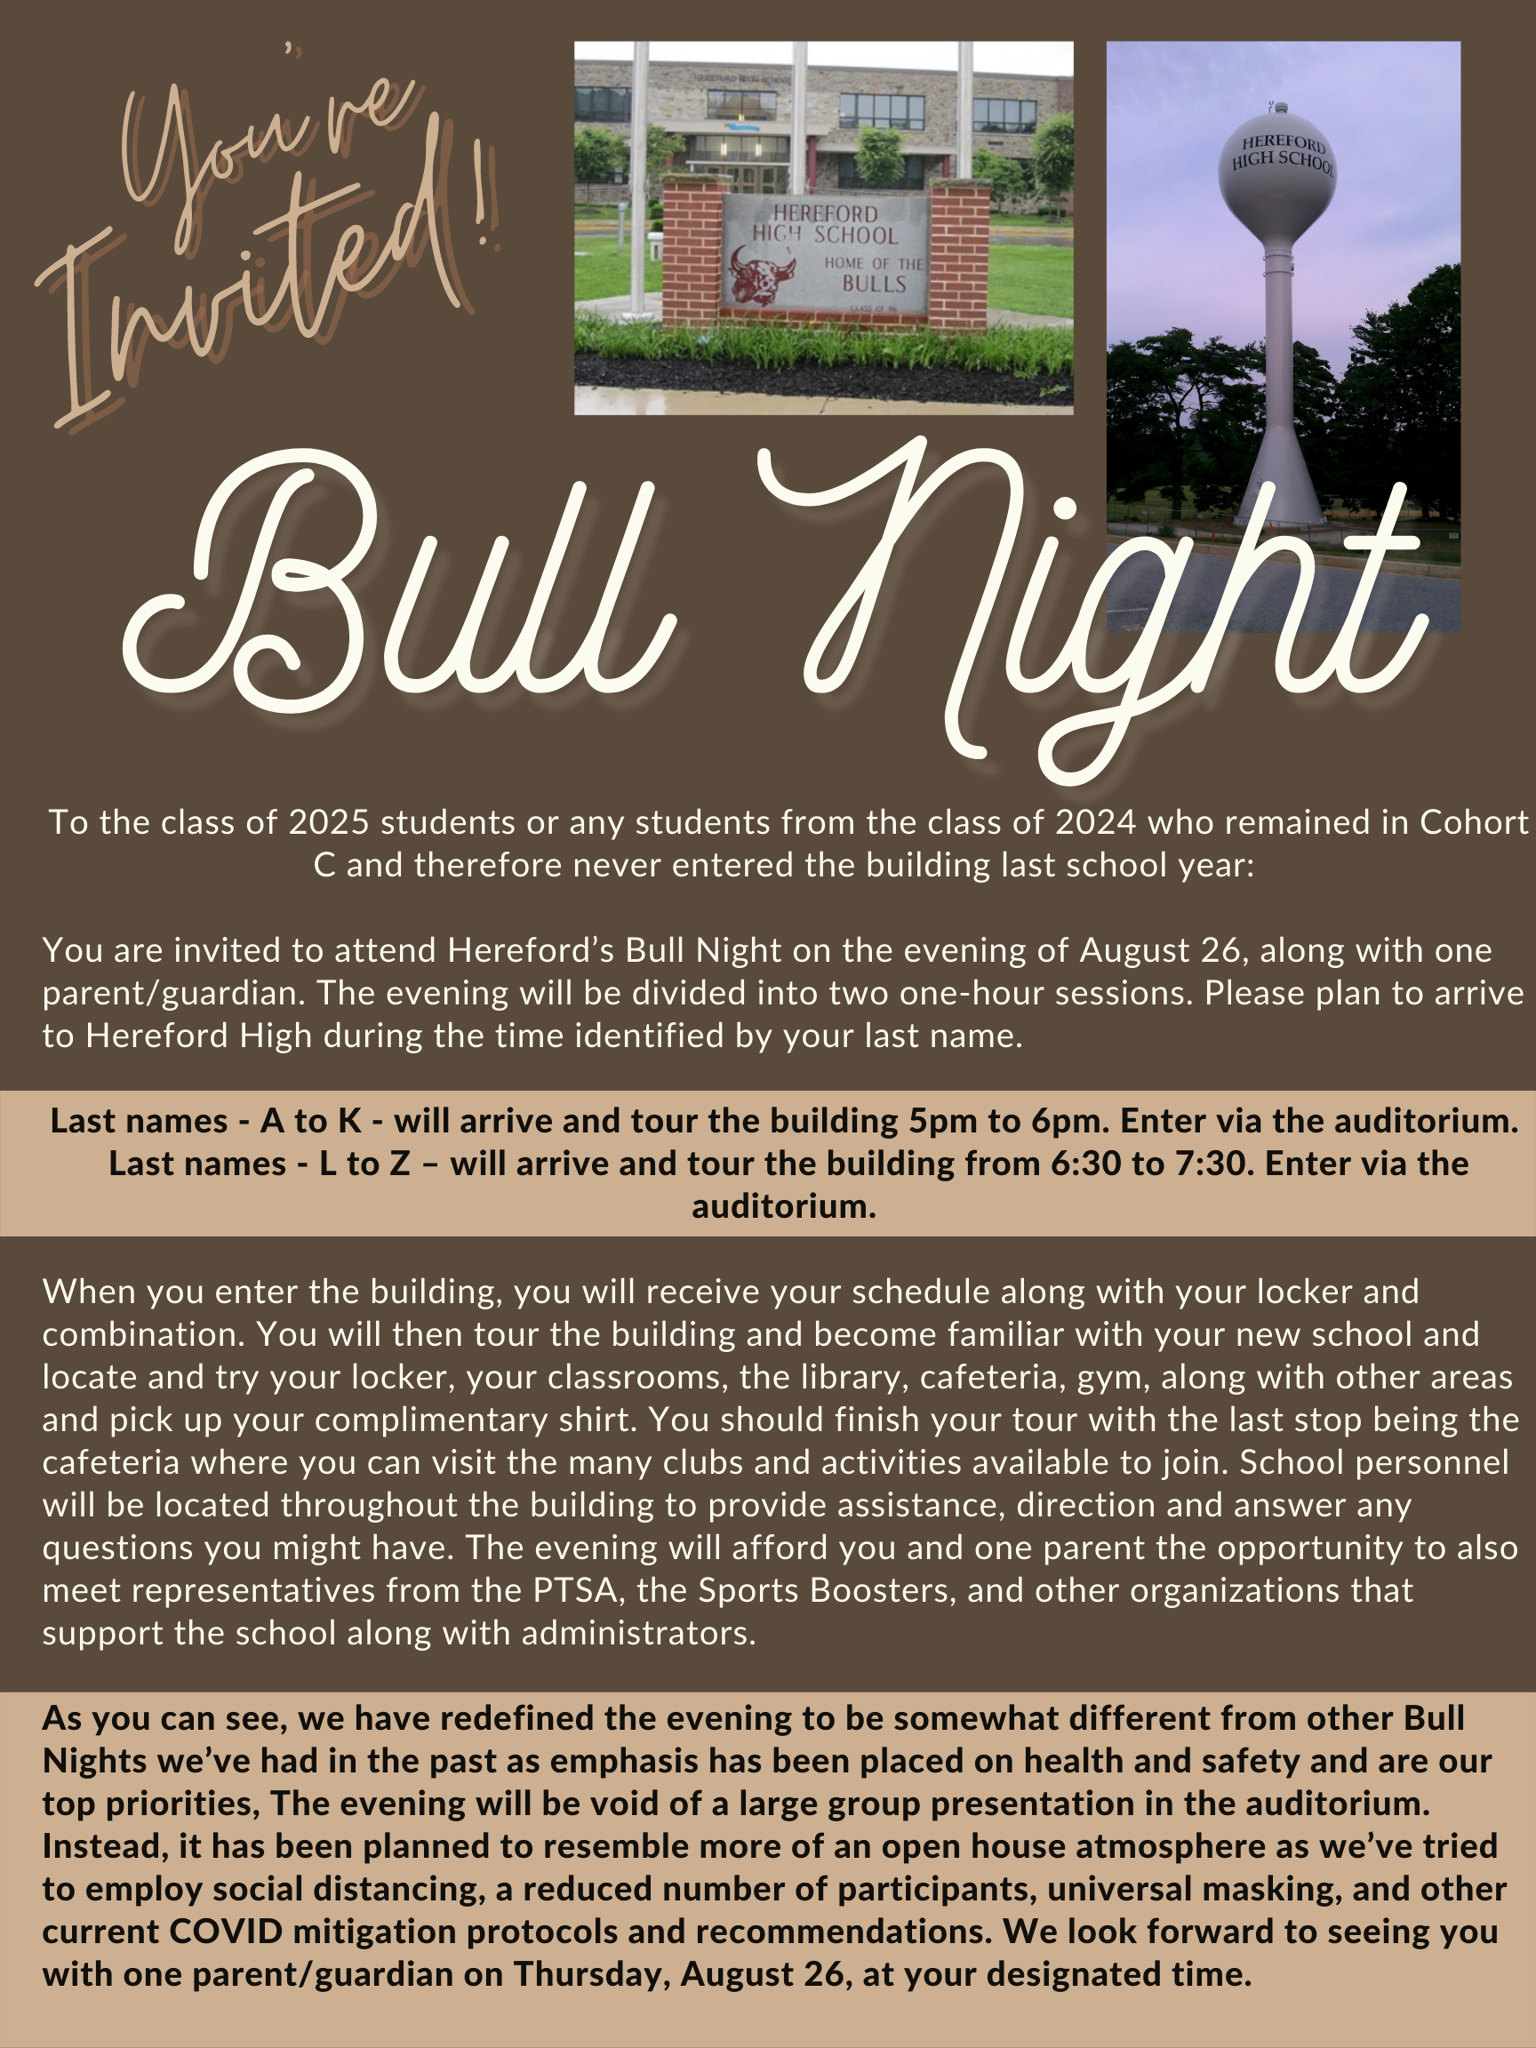
Early Entry Day for 9th Grade Students – This Friday, August 27
In addition to Bull Night, all ninth-grade students will be afforded the opportunity to attend Hereford High School on Friday, August 27. Bus transportation will be provided to and from school and students will spend the morning participating in several activities to prepare them for the first day of school. Students will be picked up at their assigned bus stop at their designated time, arrive to school, participate safely in a number of team building activities, explore the school, meet teachers, be provided a lunch and dismiss at 11:30 to ride the bus home. Parents also have the option to provide their own transportation with drop-off and/or pick-up. More details about this event will be sent out later this week in a separate Message Out by Mr. Covert, the 9th grade level administrator.

Back to School Night
We’ve scheduled Thursday, September 2nd, for our Back-to-School evening this year. At this point with rising COVID metrics and in the interest of safety, we are leaning toward making the evening a virtual event as opposed to live which would afford parents the opportunity to not have to visit the building thus limiting risk. We would structure the event as we did last year with teachers recording their classroom talks and allowing parents to access those teachers for whom their children have as teachers. We’d also create a vehicle for parents to communicate with their children’s teachers to ask questions they may have. Stay tuned, more of this as I discuss it with the faculty this week.

