2019 Student Device First Run Directions
Step 1: Log in
- Login in with your BCPS username and password.
Step 2: Open Microsoft Word 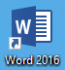
- Click the “OK” button on the Product Activated window.
- Click “Accept and start Word” button. Click “OK”.
- Close Word.
Step 3: Launch OneDrive
- Click the grey OneDrive cloud icon.
- If the OneDrive cloud icon is not visible click the hidden icons (1) and then the OneDrive Cloud (2).
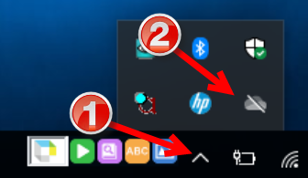
- Click the “Sign in” button.
- Enter your BCPS user ID with @bcps.org included and click “Sign in”. (ex. abc123@bcps.org)
- If prompted for credentials provide BCPS username and password (1) and click “OK” (2).
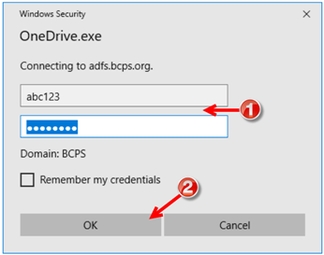
- Click “Next”.
- Click the right arrow five times and finally click “Open my OneDrive folder” button.
Step 4: Shut Down
- Click power icon at the bottom of screen.
- Select “shut down” and click OK.
- Wait for screen to power off and close the lid.

Make sure to save to the correct “OneDrive”
- Use the One Drive labeled Baltimore County Public Schools
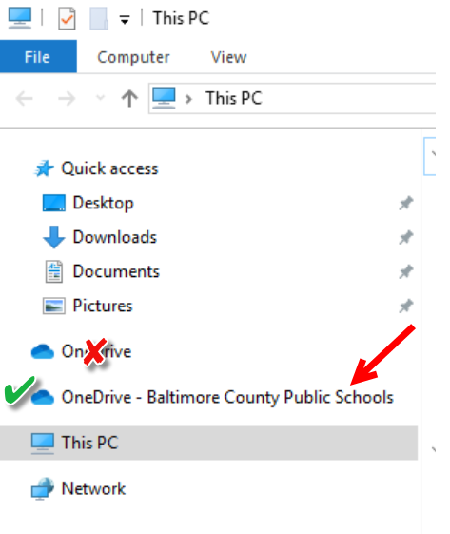

When you get home: Open Internet Explorer
- Connect to your home network.
- Go to www.pbskids.org.
- If the page loads, close Internet Explorer.
- A login page may appear like the one below. Type your BCPS username and password then click the Authenticate button.
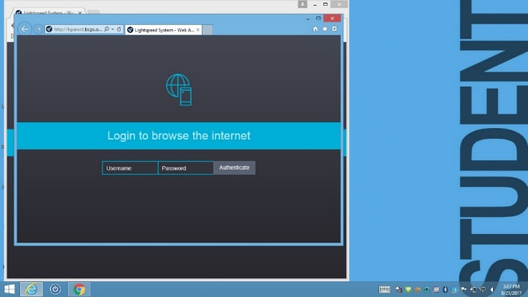
- Close Internet Explorer once site loads.
Troubleshooting Home Network Connections
- If the login page does not appear check your home network connection. Be sure other computers in the home have an internet connection.
- If the login page does appear but there is trouble connecting, try entering your BCPS credentials again.
- If you’ve tried both these troubleshooting steps and still cannot log in, let your teacher know you are having issues when you return to school.

